library("jsonlite")

library("curl")

### step 1: load the data

```{r}

df <- fromJSON("https://opendata.maryland.gov/resource/pdvh-tf2u.json")

print(df)

```

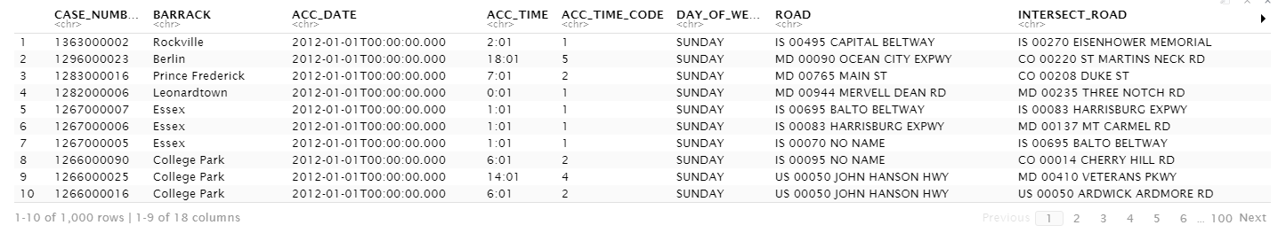

### Step 2: Clean the data - these steps appear to already be compelted when printing the DF

#df <- df[,-(1:8)] didnt need to do this with new dataset as instructed

```{r}

namesOfColumns <- c("CASE_NUMBER","BARRACK","ACC_DATE","ACC_TIME","ACC_TIME_CODE","DAY_OF_WEEK","ROAD","INTERSECT_ROAD","DIST_FROM_INTERSECT","DIST_DIRECTION","CITY_NAME","COUNTY_CODE","COUNTY_NAME","VEHICLE_COUNT","PROP_DEST","INJURY","COLLISION_WITH_1","COLLISION_WITH_2")

names(df) <- namesOfColumns

head(df)

```

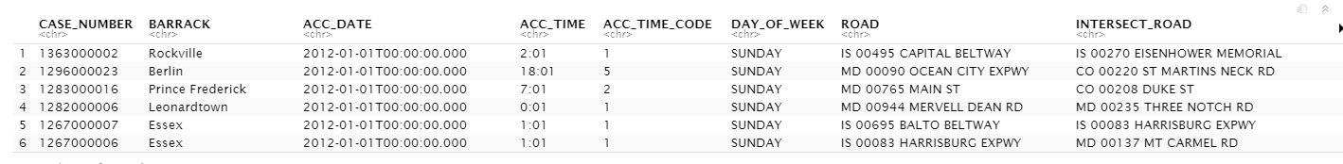

### Step 3: Understand the data using SQL (via SQLDF)

install.packages("sqldf")

library("sqldf")

```{r}

sqldf("select count(*) from df where DAY_OF_WEEK == 'SUNDAY'")

```

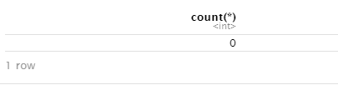

```{r}

sqldf("select count(*) from df where INJURY == 'YES' AND INJURY IS NOT NULL")

```

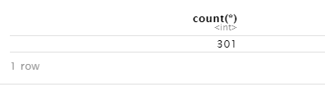

```{r}

sqldf("select DAY_OF_WEEK, count(*) from df where INJURY == 'YES' group by DAY_OF_WEEK")

```

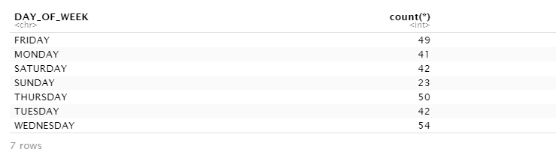

###step 4: Understand the data using tapply

install.packages("plyr")

library(plyr)

```{r}

acc_on_sunday <- tapply(df$DAY_OF_WEEK,df$DAY_OF_WEEK =="SUNDAY",count)

acc_on_sunday

```

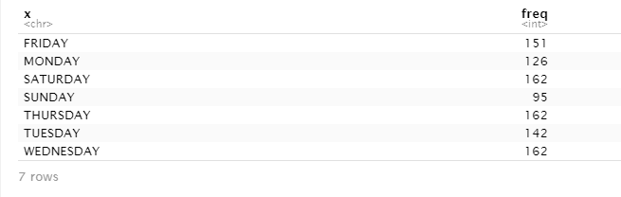

```{r}

acc_with_injury <- tapply(df$INJURY,df$INJURY == "YES",count)

acc_with_injury

```

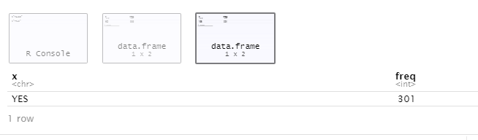

```{r}

injury_list_day <- tapply(df$DAY_OF_WEEK,df$INJURY=="YES",count)

injury_list_day

```

